A000-Can-Coastal Salish Bear mask from Longhouse and Winter Dance Ceremonies

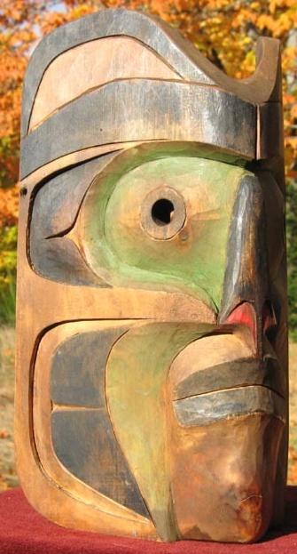

Coastal Salish mask from Longhouse and Winter Dance Ceremonies from a Northwest Coast Estate. This mask is masterly carved from very fine grained yellow cedar (with growth lines less than 1/32nd of an in. apart). The mask represents a shaman transforming into a bear, a transformation that was thought to allow the shaman to cure illnesses by to entering the bear's spirit world. The mask retains much of its original black, green and red pigmentation with a patina due to extensive tribal use. There are holes on either side of the mask to accommodate wearing straps; the eyelets are carved through. Size: 9 in. high x 5.75 in. wide x 4.25 in. deep.

These rituals, in which family names, privileges and goods such as canoes, silver bracelets and coppers were given away, was the Salish version of the Potlatch and are thought to date back thousands of years